**Make Windows Default OS In Dual Boot With Ubuntu 13.04: The Easy Way**

**<http://itsfoss.com/windows-default-os-dual-boot-ubuntu-1304-easy/>**

*By*[ABHISHEK](http://itsfoss.com/author/Abhishek/)

Several people prefer to have Windows and Linux in dual boot mode. Some of them use Linux as their primary OS while some prefer Windows as their primary OS. When you install Ubuntu along with Windows in dual boot mode, Ubuntu becomes the default OS. At the start up, if you do not choose Windows for login within 10 seconds (default Grub timeout), it boots up in to the window.

This grub behavior creates problem if you prefer to have Windows as your primary OS. You have to wait till the computer boots up and stay close to your computer to choose Windows for login. This is inconvenient, I can understand. You can [change the grub behavior to make Windows your default OS in dual boot by editing the grub configuration file](http://www.computerandyou.net/2011/08/how-to-change-the-default-boot-order-in-grub-2-in-ubuntu-10-04-10-10-and-11-04/" \t "_blank). While this is my preferred way, I can understand that as a regular Windows user you might not want to use the command line and would prefer a tool with graphical user interface.

I was asked by a few readers to provide a tutorial on using a GUI tool to change the default OS to Windows instead of Ubuntu. And hence I came up with this article to show you **how to change boot order in Ubuntu 13.04**.

**How To Change Boot Order In Ubuntu 13.04 with Grub Customizer:**

Until Ubuntu 12.04, Startup Manager was the best GUI tool to configure grub. The void of Startup Manager is (somewhat) filled by Grub Customizer. While Startup Manager was just focused on giving you few option to configure the boot menu, Grub Customizer focuses on all the aspects of customizing Grub, and hence it is a little complicated for beginners.

Install Grub Customizer in Ubuntu with following commands:

sudo add-apt-repository ppa:danielrichter2007/grub-customizer

sudo apt-get update

sudo apt-get install grub-customizer

**How To Use Grub Customizer:**

Once installed, search for Grub Customizer in Unity Dash and open it.



It required admin password of course. After that you’ll present to a screen where you can see the configuration. You can see that Windows lies at the bottom after so many Ubuntu options. All you have to do is to **move Windows over the first Ubuntu**. You can use the **arrow option** from the top menu for this task, once done, you can **save** this configuration. You can see the changed boot order at the next restart.

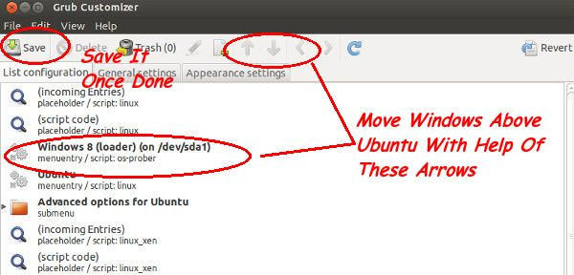

I hope the tutorial helped you to change the boot order and make Windows the default OS in your system. Questions, suggestions, a word of thanks are always welcome.